**Question 3**. Describe three categories of programming languages. List one advantage and one drawback of each.[9 marks]

High level languages are languages which are more abstract and closer to the English language. They are easy to understand compared to low level languages but generally have worse performance due to the need of them being interpreted.

Low level languages provide little abstraction and are closer to what computer can understand and decode. They perform a lot better than high level languages because they do not need to be interpreted. However, they are much harder to learn, understand, and maintain for programmers.

Machine language comprises of data and instructions expressed in 1s and 0s. This is only recognized by the computer itself. It does not require any translator of some sort, making it the fastest and most efficient. However, it is very difficult to find and fix errors in the code.

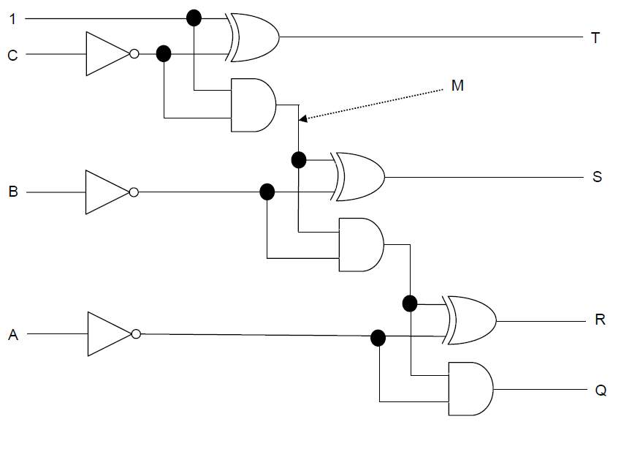**Question 4.** Use the following circuit diagram to produce the values of Q, R, S , T. [8 marks]

|  |  |  |  |  |  |  |
| --- | --- | --- | --- | --- | --- | --- |
| A | B | C | Q | R | S | T |
| 0 | 1 | 1 | **0** | **1** | **0** | **1** |
| 1 | 0 | 1 | **0** | **0** | **1** | **1** |
| 0 | 1 | 0 | **0** | **1** | **1** | **1** |
| 0 | 0 | 1 | **0** | **1** | **1** | **1** |

Question 5: Agro company sells food products . Write a program which will store product id, name and price of food item. Print the average and total price of all the items. Display the three most expensive items. Ask user to enter the details of a new item to the list and display all food items.

Sample data: ID, Name, Price

Food=[[101, “ Potato”, 12] , [102, “ Tomato”, 15], [103, “ Apple”, 4], [104, “ Rice”, 8],

[105, “ Wheat”, 22], [106, “ Oil”, 18] ,[107, “ Milk”, 4]]

Question 6: Create pseudocode from following program description:

A game is created where a user is required to guess an unknown number between 1 and 100. Each time the user guesses the program informs them if their guess in too high, too low or correct. The guessing game only finishes when the user’s guess matches the unknown number. Display how many tries user had at guessing the number.

SET number TO <get random number between 1 and 100>

correct = False

tries = 0

while correct == False:

guess = Receive from Keyboard

if guess < number:

print(“too low”)

elif guess > number:

print(“too high”)

else:

print(“correct!”)

correct = True

tries++

SEND to DISPLAY tries

Question 7: Convert the pseudocode in Question 6 to python code. Record all the guesses made by the user in a text file. When user has guessed the correct number add appropriate message to the text file.

